Liminal Spaces and the Uncanny Valley:
An Interdisciplinary Virtual Reality and Psychology Experimental Research Design

Aaron Chen, Ethan Wang, and James Kerrane
Peak to Peak Charter School

Author Note
The Technology department at Peak to Peak Charter School received funding from the Colorado Department of Education from the Career Development Incentive Program (https://www.cde.state.co.us/postsecondary/hb18-1266) to purchase virtual reality headsets and game design and development certification courseware and certification exams used by the authors in the study. Ilse Meiler and Robert Hettmansperger were the Adult Sponsors in the study who evaluated possible risks, ensured compliance with ISEF and CSEF rules, and provided guidance in the scientific process. Carla Flanhofer was the Qualified Scientist in the study who provided direct supervision of the project's human experimentation. We thank high-school psychology student Reema Patadia for the initial idea for the experimental research design. This paper was written for the Colorado Science & Engineering Fair (CSEF) Technical Writing Awards in the Senior Division. This is written as a technical report, as if it were planned to be published in a scientific journal.
We have no known conflict of interest to disclose.
Correspondence concerning this article should be addressed to the authors Aaron Chen (aaron.chen7828@gmail.com), Ethan Wang (Ethan2018196@gmail.com), and James Kerrane (hi@jameskerrane.com).
Abstract
Liminal spaces are a subset of spaces that induce subconscious anxiety, leading to potential discomfort, diminished attention, and other adverse effects. Previous studies have created similar environments by removing items, adjusting lighting, and altering human presence; however, many studies overlook the potential of object orientation to increase the liminality of a setting. In our experiment, we utilized expertise from an online Unity certification course and research design plans from our school's Senior Psychology course to develop a VR simulation for experimental purposes. During our data collection process, the control group experienced a set of commonly known spaces (classroom, grocery store, and library) without any alterations. In contrast, the experimental group would see these spaces with disoriented objects and no other changes. Both groups were prompted to advance through each room as they pleased by pressing a large button. During the experiment, we tracked the participants' time spent in each room and provided a survey asking about comfort levels in each space. Our findings revealed that students were less comfortable in disoriented spaces, yet, oddly, they spent longer in those spaces. We attributed this correlation to students being unfamiliar with those environments and staying longer to explore the new spaces. As society emerges from COVID-19, bringing people back into public spaces, our discoveries about space orientation and comfortability could support return initiatives. On a broader scale, this demonstrates VR technology's potential within psychological experimentation and broader research implementation, revolutionizing human data acquisition.
Keywords: virtual reality, liminal spaces, uncanny valley, comfortability, COVID-19

The Uncanny Valley and Virtual Reality Environments
Our study tackles how structural changes in expected environments can lead to an “uncanny valley” effect for a space, which is a reported unease from and what makes a space either comfortable or uncomfortable for those occupying that space (Diel & Lewis, 2022). We altered the organization of objects in different virtual reality environments in an organized or an unorganized manner. These structural changes in the environments, such as soup cans on the ground of a supermarket or overturned desks in a school environment, lended to the “uncanny valley” effect of an otherwise known space by highlighting a discrepancy in expectations. The background for our research problem comes from the understanding of liminal spaces, which is often associated with spaces that cause some sort of discomfort or unease (Mauro, 2021). This research is important because, as people are coming back from COVID-19, many people are very unwilling to go back in person. The purpose of this research is to help employers, school personnel, and people manage public spaces to increase the comfort and the amount of people returning to their locations.
Developments in virtual reality (VR) technology provides a new experimental framework for prototyping, designing, and implementing psychology experimental design pitches. The ability to create virtual worlds allows researchers to conduct experiments that are unfeasible or impossible in physical reality, creating a new frontier for psychological experimental design (Brookes et al., 2020). Psychological questionnaires in response to virtual reality experiences have shed insight on how virtual reality can be used as a tool in psychological experimental design (Nijland et al., 2021).
In the four Psychology course sections at Peak to Peak Charter School, students created their own proposal for a psychological research project design featuring virtual reality to test a psychology concept. These designs were pitched to each class section,, then the class voted on an experimental design to pursue further. Through this process, four experimental design pitches were brought to our team to decide on an experimental design to prototype and bring to virtual reality. We chose a case study experiment out of this process by Reema Patadia to modify and implement into a virtual reality study, which led to our study of the uncanny valley effect for environments.
We used a case study experiment to show the feasibility of virtual reality technologies in creating student-driven psychological experimental design environments. We showed that through the use of video game engines such as Unity, experimental design frameworks such as Unity Experimental Framework (UXF) (Brookes et al., 2020), and a research pitch design process from psychology students, virtual reality can be an effective tool to prototype psychology research designs.

Method

Human Experiment Methodology and Safety Protocols

Participants
Participants were all 18 years of age or older, of any gender and racial/ethnic composition. Participants were required to be students at Peak to Peak Charter School with a signed informed consent (see Appendix A).

Recruitment
Participants were recruited from psychology class sections at Peak to Peak Charter School. They were invited to participate during time given as part of the psychology curriculum and were given an informed consent if they choose to allow the use of their data.
Methods
Students were asked to enter a VR simulation where data would be collected from the time spent within each VR space and a post-experiment comfort survey (see Appendix D). The experiment took approximately 5–10 minutes to complete for each participant.

Risk Assessment
During the virtual reality experience, participants were exposed to the risk of the normal side effects of virtual reality such as headaches, tiredness, eyestrain, and neck and shoulder pain. There also may be issues of disorientation and loss of balance, all risks affected by conformability within VR. However, the experiment was designed for a high comfort level. Participants were allowed to remove the VR headset at any time, as stated within the informed consent and inside the application. In addition, the surrounding space was cleared to avoid any possible collisions during the experiment, and the Quest Guardian software was set up prior to the experiment to warn participants if they might collide into an object in real life.
For the researchers, there is no particular risk outside any harm caused by testing in VR such as nausea or motion sickness. Researchers were instructed to follow the procedures of the place the experiment is being conducted (usually Peak to Peak Charter School), and the room supervisor for safety precautions if a participant is showing signs of sickness.

Protection of Privacy
No identifiable information was collected from the participants, and only the times from the simulations and the survey responses were recorded. Any identifiable data collected from the participants through the informed consent process was destroyed upon the completion of the experimental process. The only people with access to the information from the survey were the three students in charge of the process and the students’ mentors.

Informed Consent Process
Participants were informed about the purpose of the study and what they are asked to do with an informed consent that they signed (see Appendix A), and an overview of the process in the procedure. Participants were reminded that their participation was voluntary and could be terminated at any time.
Measures
The organization of objects in virtual reality environments indicating a discrepancy in expectations of a person in an environment studies the “uncanny valley” effect of an otherwise known space. By turning common environments into liminal space, unsettling feelings like unease can be measured with the amount of time someone spends in a room before moving onto the next room, and with the perceived unease of a participant through a post-experiment survey.

Research Question
Does the organization of an otherwise known public space cause users to feel unsettling feelings?

Hypotheses
- People placed in spaces where the objects appear scattered or recently used will spend less time in those spaces than people placed in spaces where the objects are neatly organized.
- People placed in spaces where the objects appear scattered or recently used will feel more discomfort than people placed in spaces where the objects are neatly organized.

Engineering Goal
The engineering goal is to create a virtual reality (VR) simulation that creates a symbolic representation of real life spaces to allow for accurate data collection on a prediction about how people would react to similar situations in real life.

Procedure
The procedure at the beginning of the simulation was the same for both control and experimental groups. Participants entered the program, and the program automatically decided—using a pseudorandom generator (Unity's Random class)—whether they were placed in the control or experimental group. Game engines like Unity cannot generate fully-random numbers, but pseudorandom numbers are designed to be used in game settings and are acceptable for this purpose (Unity — Scripting API, n.d.). This will reduce potential bias by a blind study, because the procedure will be followed by the researcher without the participant or the researcher knowing which group they are a part of.

Script for researchers:
- Read the following to each participant: “Hello, thank you for participating in today's VR experiment. In this experiment, you are going to enter three spaces modeled after real life places in virtual reality. You will have complete freedom to explore the space and when you are ready to move to the next room you will press any button on your controller. After you have pressed the button, you will be transported to the next room until there are no rooms left. Participation in this experiment is voluntary, and you will not be penalized for participating or exiting the experiment at any time. Please read and sign the informed consent form if you consent to be a part of this research study.”
- The participant was shown a guide on the controls for how to move around in the experience (see Appendix C) and how to move to the next room using the buttons on their controller.
- The participant put their headset on and click a “Start” button, at which point the program used a pseudorandom number generator to randomly assign participants into either a “Control” or an “Experimental” group.

Control
- The VR experience will load pseudorandomly into one of three environments: An organized store, classroom, or library environment. Once the environment loaded, the total time in each environment before moving onto the next environment was recorded by the game.
- The same process was repeated for all three spaces and the times will be recorded for each to be compared to the experimental group.
- The experiment concluded after ten minutes had elapsed, or when the participant had chosen to move on after the third space.
- A comfort survey was administered inside the headset (see Appendix D), where participants were able to respond by clicking buttons on the controller.
- The participant was thanked for their participation and provided the debrief (see Appendix B)

Experimental
- The VR experience loaded pseudorandomly into one of three environments: A disorganized store, classroom, or library environment. Once the environment loaded, the total time in each environment before moving onto the next environment was recorded by the game.
- The same process was repeated for all three spaces and the times were recorded for each to be compared to the experimental group.
- The experiment concluded after ten minutes have elapsed, or the participant has chosen to move on after the third space
- A comfort survey was administered inside the headset (see Appendix D), where participants were able to respond by clicking buttons on the controller.
- The participant was thanked for their participation and provided the debrief (see Appendix B)

Data Collection
The data collected were the time that participants spent in each room and the results of a survey conducted after participation that asks about comfort levels (see Appendix D). This post-experiment survey was administered inside the headset anonymously, with the only data being recorded with the survey is whether the participant is a member of the control or the experimental group. After the completion of the virtual reality experience, the headset sent a secure and POST request over HTTPS to a connected to an external PHP database with a current timestamp, whether the participant was in the control or experimental group, inputted survey responses, and the amount of time spent in each room.
Results
In the context of our research question, our data reflected interesting points, most notably that in liminal spaces, comfortability decreased while time spent increased. This was most likely due to increased intractability/curiosity, which diverted the attention of the subjects from moving on to the next room. While it proves the uncomfortability that liminal spaces are meant to create, it poses the idea that in spite of being in a space that causes a negative feeling to occur, people are willing/more likely to explore their surroundings. However, since this was done in a virtual environment, it is unknown whether these results would translate one-to-one to real life as these experiments were conducted in a normal space. As well, the virtual environments themselves were not created in a way that perfectly reflected reality, so there could be some disconnect as well.

Table 1
Extrapolated Comfortability Score from Survey Responses
Group | Control (Typical environment) | Experimental (Disorganized environment)
Store Comfortability
28.00% |  | 33.75%
Class Comfortability
36.00% |  | 33.75%
Library Comfortability
52.00% |  | 36.25%

Note. The comfortability percentage is calculated from the survey responses. Participants were asked to answer “Strongly agree”, “agree”, “neutral”, “disagree”, and “strongly disagree” to the question “I felt at ease in the environment most similar to a (store/class/library).” Strongly agree was mapped to a score of 100%, with “agree” mapped to 75%, “neutral” 50%, “disagree” 25%, and “strongly disagree” 0%, and the score was averaged for each group.

Table 2 (table of all the produced graphs)
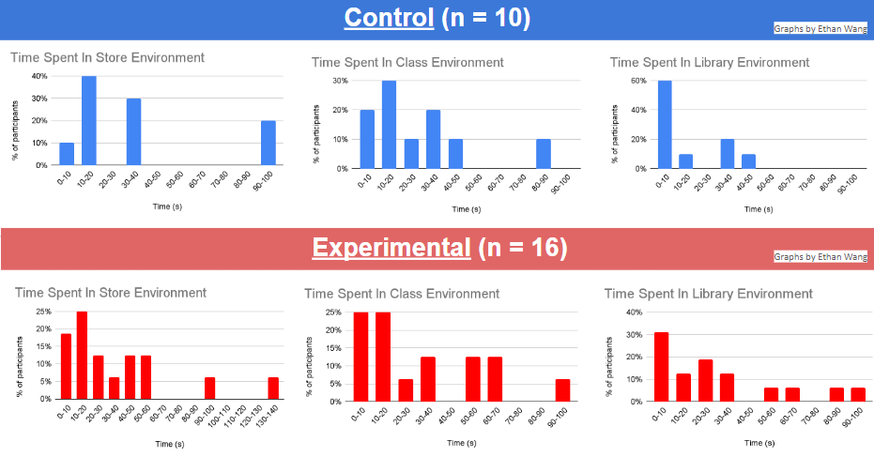

Discussion
To ensure the difference observed in both the comfortability and the time spent in the room was significant and/or able to be extrapolated to a wider population, a two sample t-interval was created to determine if there was a significance difference at 95% confidence (Note: all times from all scenes were pooled together so the average shown below is the average time spent overall).

Time Spent

xnormal = 26.96666667
Sx-normal = 25.06334504
nnormal = 30

xliminal = 32.4375
Sx-liminal = 30.47559627
nliminal = 48 (]]
Resulting Confidence Interval @ 95% Confidence = (-18.13, 7.1875)

This confidence interval means that we are 95% confident that the true difference in time spent in liminal versus non-liminal is between (-18.13, 7.1875). Since this interval contains 0, that means there is a possibility that there is no difference in time spent in the different spaces. In addition to the confidence interval, a 2-sample t-test was performed as well (H0: u1=u2, Ha u1 != u2), resulting in a p-value of 0.392, and a t-statistic of -0.862. Since the significance level for both tests was set at 0.05, we can conclude that there is no statistically significant difference in being in either a liminal or a non-liminal space. However, due to the low sample size of people that participated (in addition to the possibility of doing statistical tests for each scene individually), further experimentation/testing would be necessary in order to fully prove if the liminality of a space does or does not affect time spent in it.
Conclusion

Although a limited sample size contributed to a lack of statistical significance in the different in participant comfortability and time spent between liminal or non-liminal spaces, preliminary results show people placed in spaces where objects appear scattered or recently used will spend more time in those spaces than people placed in spaces where the objects are neatly organized. These results also show that people placed in spaces where the objects appear scattered or recently used will feel more discomfort than people placed in spaces where objects are neatly organized. Our research also proves our engineering goal of creating a virtual reality simulation that represents real life spaces for accurate data collection, showing a viable case study experiment for further virtual reality endeavors.

References
Aoyagi, S., Fukumori, S., Hirose, K., & Kitamura, T. (2023). Examining the Factors of Place Sameness: A Classroom Re-creation Task in a Virtual Environment (arXiv:2305.04450). arXiv. https://doi.org/10.48550/arXiv.2305.04450
Brookes, J., Warburton, M., Alghadier, M., Mon-Williams, M., & Mushtaq, F. (2020). Studying human behavior with virtual reality: The Unity Experiment Framework. Behavior Research Methods, 52(2), 455–463. https://doi.org/10.3758/s13428-019-01242-0
Cheng, M., Cui, H., Yu, D., & Zhang, Z. (2023). Uncanny Valley Game in Virtual Environments. Highlights in Science, Engineering and Technology, 39, 89–94. https://doi.org/10.54097/hset.v39i.6498
Diel, A., & Lewis, M. (2022). Structural deviations drive an uncanny valley of physical places. Journal of Environmental Psychology, 82, 101844. https://doi.org/10.1016/j.jenvp.2022.101844
Mauro, L. (2021). Into the Uncanny Valley: Liminal Places as the Locus of the Unsettling in Horrific Fiction. https://doi.org/10.13140/RG.2.2.22401.38240
Myers, David G. Myers’ Psychology for AP. Worth Publishers, 2014.
Nijland, J. W. H. M., Veling, W., Lestestuiver, B. P., & Van Driel, C. M. G. (2021). Virtual Reality Relaxation for Reducing Perceived Stress of Intensive Care Nurses During the COVID-19 Pandemic. Frontiers in Psychology, 12. https://www.frontiersin.org/articles/10.3389/fpsyg.2021.706527
Unity - Scripting API: Random. (n.d.). Unity Documentation. Retrieved December 5, 2023, from https://docs.unity3d.com/ScriptReference/Random.html

Appendix A

“Informed Consent Document for Participants”
You are being asked to participate in my psychology research design study in order to study a concept in the field of social psychology (more information will be provided in a later debrief). For this project, you will enter a VR simulation of a public space where you will be free to move around. When you are ready, you will be able to move to another space. You will be able to explore 3 separate spaces, and the total exploration should take no longer than 10 minutes. Your participation is completely voluntary, and you may end participation at any time. There are no consequences for declining or withdrawing from the study. Potential risks or discomforts could be headache/dizziness from being in VR and potential discomfort over being in a public space alone. The benefits of this research will be to help researchers better understand if a real-life social psychology concept can be observed in a virtual setting. Any identifying information will be kept confidential when discussing results of this study, and the informed consents will be discarded in a shred box when the research is complete. There are no incentives for participation. You may ask any questions at this time, and you can contact ewang01@bvsd.org for more information about the research or participant’s rights at the end of the study.

Appendix B

“Debrief Statement for Participants”
Thank you for your participation in my psychology research design study. For this study, we were exploring the concept of public spaces and how to manipulate a public space in order to make someone more or less comfortable with the space. If you are interested in the final results of this study or if you have any additional questions, you may email us at ewang01@bvsd.org.

Appendix C

"Oculus Quest 2 Controller Tutorial Guide Given to Participants"
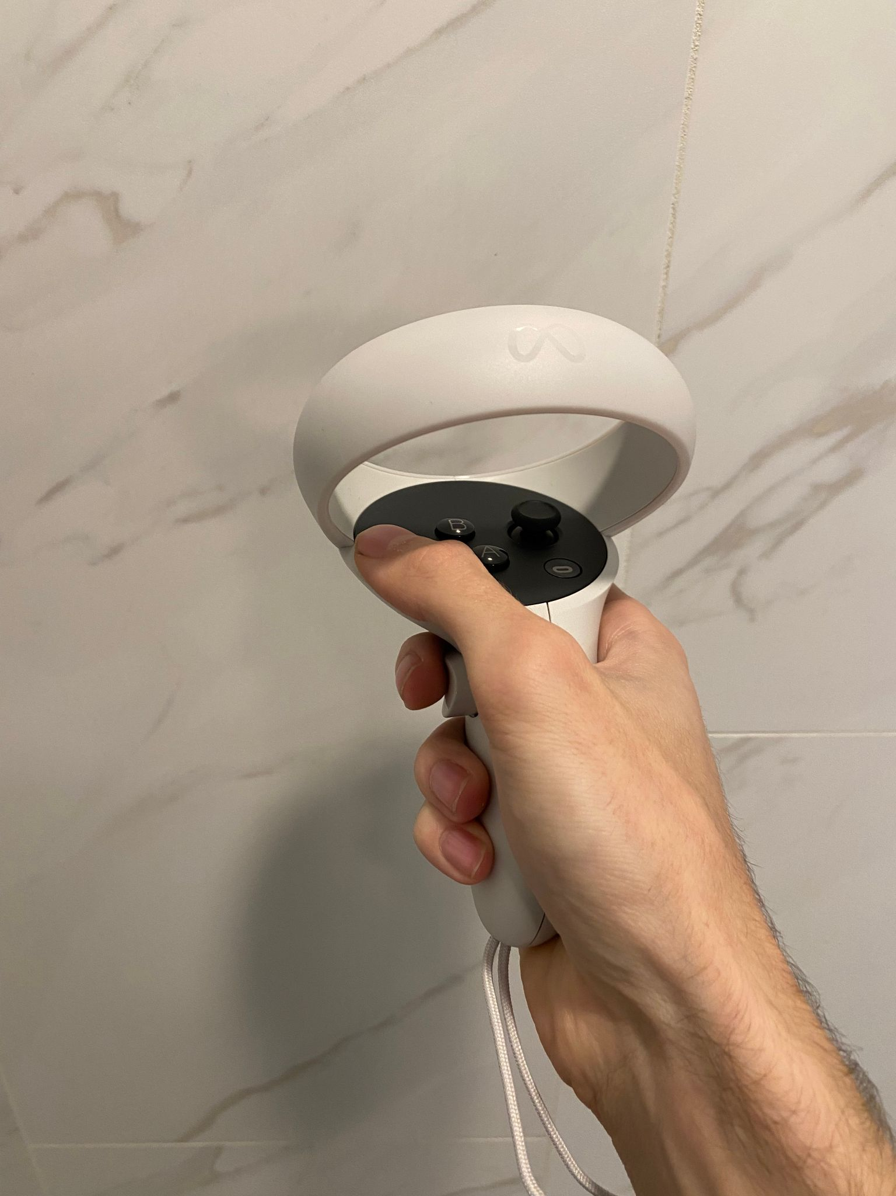
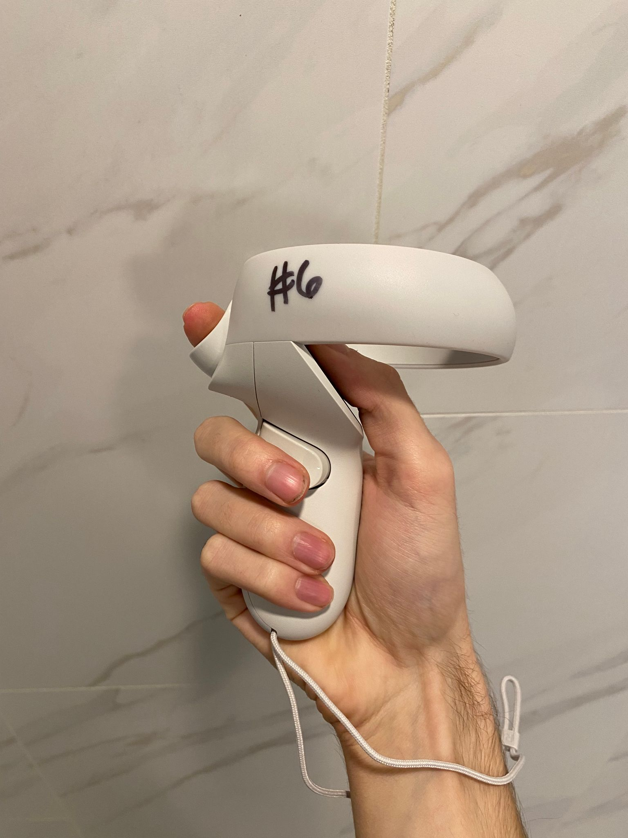
Always use hand-strap
Press either trigger at any time to move to next room
Use the thumbstick to move around

Appendix D
“Post-Experience Comfort Survey”
